Instruction Manual
15L Evaporative Cooler
Model: HECS15

READ AND SAVE THESE INSTRUCTIONS

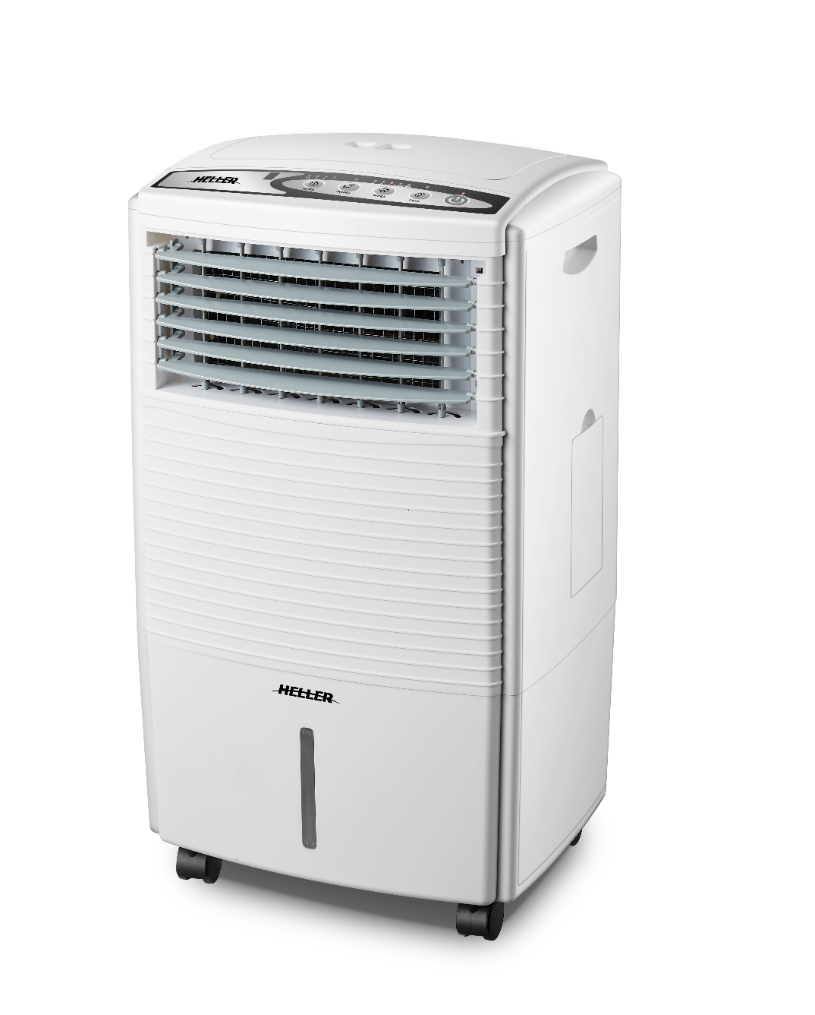
Please read and follow the instructions in this user manual even if you feel you are familiar with the product, and find a place to keep it handy for future reference.
For your convenience record the complete model number (located on the product identification plate) and the date you received the product, together with your purchase receipt and attach to the warranty and service information. Retain in the event that warranty service is required.
NOTE: The rating of this product (as marked on the product identification plate) is based on specific loading tests. Normal use or the use of other recommended attachments may draw significantly less power.

IMPORTANT SAFEGUARDS
When using any electrically powered product, basic safety precautions should always be followed, including the following:

PLEASE READ ALL INSTRUCTIONS CAREFULLY BEFORE USING THIS PRODUCT

WARNING!: - to reduce the risk of fire, electrical shock or injury to persons or property:

- Always operate the product from a power source of the same voltage, frequency and rating as indicated on the product identification plate.
- Remove the unit from its packaging and check to make sure it is in good condition before using.
- Do not let children play with parts of the packaging (such as plastic bags).
- Close supervision is necessary when the product is used by or near children or infirm persons. Do not allow children to use it as a toy.
- If the supply cord is damaged, it must be replaced by the manufacturer, its service agent or similarly qualified persons in order to avoid a hazard.
- Do not operate any product with a damaged cord or plug, or after the product malfunctions, or is dropped or appears damaged in any way. Return the complete product to the place of purchase for inspection, repair or replacement.
- Before unplugging the power cord, be sure to turn the power off. When touching the unit, be sure your hands are dry to prevent electrical shock.
- Never install the unit where it is exposed to direct sunlight, excessive moisture/rain, dust and lack of ventilation near any heat sources.
- Avoid making contact with moving parts. Never insert fingers, pencils or any other objects through the guards whenever the power plug is connected, especially while the unit is working.
- Always place the cooler on a stable, level surface when operating to prevent the fan from overturning. Do not run the power cord under carpet. Do not cover the power cord with throw rugs or runners. Route the power cord away from walking paths so that nobody can trip over it. The cable should be kept away from heat, sharp edges and oil.
- To reduce the risk of electric shock, do not immerse or expose the product or flexible cord to rain, moisture or any liquid other than those necessary for correct operation of the product.
- This product should not be used in the immediate vicinity of water, such as bathtub, washbowls, bathroom swimming pool etc. Where the likelihood of immersion or splashing could occur.
- Switch off and unplug from outlet when not in use, before assembling or disassembling parts during filling, and before cleaning. Remove by grasping the plug - do not pull on the cord.
- Be sure that no other high current appliances are plugged into the same circuit as your fan, as an overload can occur.
- Avoid the use of an extension cord as the extension cord may overheat and cause a risk of fire.
- Do not use the appliance for other than its intended use.
- Do not use outdoors. FOR INDOOR USE ONLY.
- Do not leave the appliance unattended when switched on.
- Do not cover the grill, or operate in close proximity to curtains etc.
- The use of attachments or accessories not recommended or sold by the product distributor may cause personal or property hazards or injuries.
- This product is intended for normal domestic/household use only.
- Never leave a working appliance unattended, even for a short period of time – always switch it off. Please unplug the appliance from the power supply when not in use.
- Use this cooler as described in this manual. Any other uses, not recommended by the manufacturer, may cause fire, electric shock, or injury to persons and may void the warranty.
- This appliance is not intended for use by persons (including children) with reduced physical, sensory or mental capabilities, or lack of experience and knowledge, unless they have been given supervision or instruction concerning the use of the appliance by a person responsible for their safety.
- CAUTION: To reduce the risk of electric shock, DO NOT remove the cover (or back) whilst the unit is in operation or connected to the mains supply.
- This product operates with water - operate and move the product with extreme care.
- Always operate and store the unit in an upright position.
- The installation of a residual current device (safety switch) is recommended to provide additional safety protection when using electrical appliances. It is advisable that a safety switch with a rated residual operating current not exceeding 30mA be installed in the electrical circuit supplying the appliance. See your electrician for professional advice.

Product Introduction & Features
Evaporative air cooling is a natural way of cooling, similar to a breeze flowing across the water which drops the temperature at the beach, and has a relaxing cooling effect on people.
When water as a liquid evaporates in to the air, the result is a mixture of air and water molecules. This chemical change requires heat, thus energy or latent heat is taken from the air molecules - dropping the actual temperature of the air.
Air contains dust, pollen and other pollutants. The evaporative air cooler cleans the air providing cool, fresh, clean healthy air.
For best operating performance position the unit in a location that will create a “flow through” air effect. The greatest cooling effect will be felt if the unit is operated in a partly opened doorway or window with the “cool” conditioned air directed into the room to be cooled. It is important to also have a door or window partly opened away from the cooler to create this “flow through” effect.
On days of high humidity, the cooling effect may be significantly reduced as the air entering the filter may already be saturated with moisture. On days like this it may be better to switch the cooling feature OFF and operate the unit as a fan only.

PARTS & FEATURES
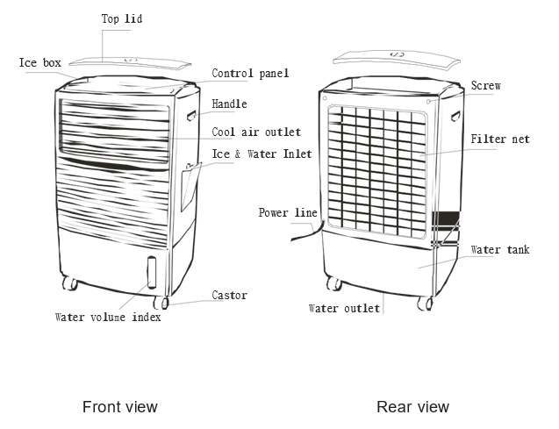

CONTROL PANEL LAYOUT
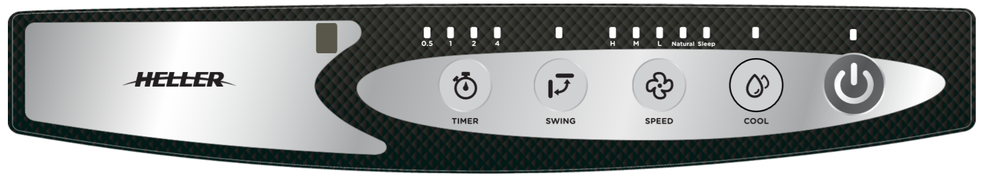

REMOTE CONTROL
Note: 2 x AAA batteries are not included.
The Cooler comes with a remote control for your convenience.
The functions on the remote control are the same as the buttons on the evaporative cooler.
To install the batteries, first remove the back of the remote control by sliding the back battery cover off.
Insert the batteries inside the battery compartment matching polarity icons with those in the battery compartment and then refit the cover securely.
Battery Type: 1.5V 2 x AAA
Do Not mix new and old batteries in the remote control.
To prevent corrosion, remove the batteries if the remote control will not be used over a lengthy period.

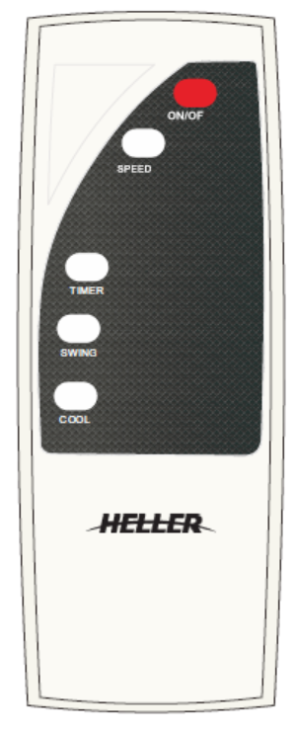

BEFORE FIRST USE
Before use, remove all packaging and inspect the appliance for any damage. If there appears to be any damage, please take the unit back to place of purchase for a replacement.

PREPARATION
- When ready to use the cooler, make sure that the power switch is set to OFF and the unit is disconnected from the power point.
- Ensure the rubber drain plug is fully inserted into the hole (located in the rear of the unit at the bottom).
- Remove the top cover and carefully pour clean cold water into the water tray.
- The water will drain down through the hole into the water tank inside.
- Fill until the level has reached the Maximum mark on the water level indicator which is located on the lower front of the unit. DO NOT OVERFILL.
- Ice blocks can also be added which will help cool the water/air.
- Do Not Fill with any liquid other than clean cold water. Do Not add any additives to the water.
- Refit the Cover before turning on.

OPERATING INSTRUCTIONS
NOTE: Before inserting the plug into a power outlet, make sure that the correct voltage being used corresponds to what is indicated on the rating label, and that the socket has an earth facility.
CAUTION:
- Select a suitable location for the fan. Always choose a safe location in accordance to the safely recommendations outlined.
- Ensure the cap on the Water drainage outlet of the unit is tight. Pour clean cold water into the water filler area, observing the water level indicator in the bottom front panel.
- DO NOT SPILL OR ALLOW WATER TO COME IN CONTACT WITH THE CONTROL PANEL.
- Do not overfill past the MAX water line.
- Do not pour water into the ice tank.
- Do not allow the combined use of water and ice to overfill the water reservoir.
- When moving the unit, do so with extreme caution; do not spill any water in the reservoir. The unit should be moved slowly and in a sideways direction.
- Always keep the unit upright.

- ON/OFF
- Insert the power plug into a power point and switch on. The ON/OFF indicator light will on.
- Press the ‘ON/OFF’ button on the control panel (or remote control). The unit will start in the default “LOW” speed as indicated by the indicator light and Normal Mode.

- MODE: There are 2 mode functions Nature or Sleep.
- Nature mode: Press the “Speed” Key to switch to the Nature mode. The indicator light of Nature will be on once in the Nature model. The “Nature” variable speed wind mode automatically selects one of three variable speed wind speed patterns. Each pattern produces a different wind pattern depending on the speed setting selected. Nature mode can be operating HIGH or MEDIUM or LOW speed.
- Sleep Mode: Press the “Speed” Key to switch to the Sleep Mode. The indicator light of Sleep mode will be one once in Sleep mode. The “Sleep” variable speed window allows you to set the product so that the wind speed will decrease gradually from a high speed to low (depending on the original fan speed selected by the user).
The variable speed wind speed will simulate the flow of an evening breeze slowing to a light variable speed night breeze.

- SWING:
- Press the button if you want the vertical louvers to swing from left to right.
- Press it again to stop the vertical louvres from swinging.
Note: The Horizontal louvres can be manually adjusted to direct the air higher or lower.

- SPEED:
- By default, when the unit is turned “On”, it starts at “Low” Speed.
- Each press of the “SPEED” button advances the Speed setting as indicated by the lights above the “SPEED” button. Or choosing the model. Continue to press the button to cycle around.
- Press the “ON/OFF” button to turn the appliance off.

- TIMER:
- Use this power-saving feature if you want the appliance to turn off automatically.
- To select the “OFF” time, press the “TIMER” button once. It will advance to 0.5H as indicated by the indicator lights above the “TIMER” button. The cooler will turn off after approximately 0.5 hours.
- Each consecutive press will advance the timer at 0.5H increments until it reaches a maximum time of 7.5H.
The time set will be indicated by the sum of the lights which are illuminated. i.e. if the 0.5H + 2H + 4H lights are illuminated, this adds up to be 6.5 hours. The cooler will turn off after approximately 6.5 hours.
- To turn the Timer “OFF”, or reset to a new time, continue to press the “TIMER” button until it cycles back around where no time lights are illuminated.
- Press the “ON/OFF” button to turn the appliance off.

- COOL MODE FUNCTION:
- Press the “COOL” button if you want to have cooler wind blowing from the air cooler. (Please refer to section “Guide to Evaporative Coolers”).
This activates the cooling water mechanism inside the appliance causing the air to be cooler.
The indicator light above the button will be illuminated when this feature is on.
- Press the “COOL” button again to turn this function off.
- Press the “ON/OFF” button to turn the appliance off.

NOTE: All of the above can be operated via the remote controller.

CARE & CLEANING
NOTE: If the power cord set of this appliance becomes damaged, discontinue use. Repairs should be undertaken only by a qualified technician.
CAUTION: To avoid of electric shock, you must always switch off and unplug the fan before cleaning.
To ensure effective humidifying and filtering, it is recommended that the filtering system be cleaned once every 1-2 months.
- Your appliance must be switched OFF via the main power supply and unplugged, and allow it to cool down before proceeding with any cleaning, assembling or disassembling.
- Remove any water which is left over in the water tank. Take the appliance outside and remove the drain plug in the rear of the unit. Water will pour out from the bottom of the appliance. Replace the drain plug when empty.
- Be careful not to tip or knock the appliance over.
- Clean the air cooler regularly especially the rear air inlet filter. Do not allow this filter to become blocked. This can be cleaned by using a vacuum cleaner hose with a brush attachment. Ensure the mesh is dry before vacuuming. Alternatively, the mesh can be removed for washing. To do this, loosen the screw and then pull the mesh out. Wash using a soft damp cloth or rag and mild detergent, then wipe dry. Refit the mesh and clip it securely into place.
- Clean the housing with a damp cloth, a vacuum cleaner or a dusting brush.
- We recommended lightly running a vacuum cleaner brush nozzle over the louvers to remove any dust or dirt that may have accumulated.
- Never use flammable or abrasive cleaning agents such as benzene or spirits to clean the appliance.
- Never immerse the appliance in water.
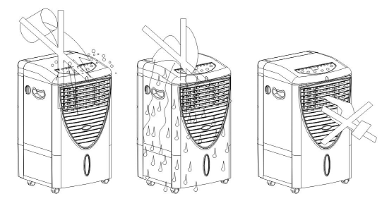

STORAGE
- Your appliance must be switched OFF via the main power supply and unplugged and allow it to cool down before proceeding with any cleaning, assembling or disassembling.
- Ensure all water is removed from the appliance. Allow the unit to run for 1-2 hours without water so it dries quicker. More time may be required depending on how humid the ambient air is.
- Coil the power cord loosely and place it next to the unit.
- Remove the batteries from the remote control.
- When the appliance is totally dry, store in a dry well-ventilated area.

TROUBLESHOOTING
Always check full product operation as detailed above before returning any product as faulty.
On humid days the unit may not appear to be cooling correctly. This is due to the air already being saturated with water. Adding more water to the air will not result in reducing the air temperature. In these conditions, it is advisable to operate the unit as a fan to circulate room temperature air.

SPECIFICATIONS
Model | HECS15
Description | 15L Evaporative Cooler
Rated voltage frequency | 220-240VAC ~ 50Hz
Input power | 85W
Water Tank Capacity | 15 Litres
Net Weight | 7.5kg
Unit’s Dimensions | 380 x 290 x 700mm

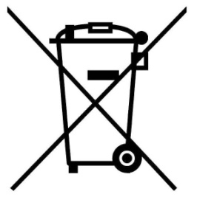
RECYCLING
For further information, please contact your local or regional authorities.
Electronic products not included in the selective sorting process are potentially dangerous for the environment and human health due to the presence of hazardous substances.

CUSTOMER SERVICE
Australian Customer Service

GAF Control (Sales) Pty Ltd
P.O Box 19
Altona North Victoria 3025
Phone: 1300 659 489
Hours: 9am-5pm (EST) Mon-Fri
www.gafcontrol.com.au
*This product may vary slightly to the product illustrated due to ongoing product development.

